Examples of climate change adaptation measures in the Randstad Region

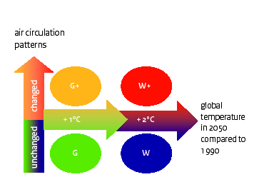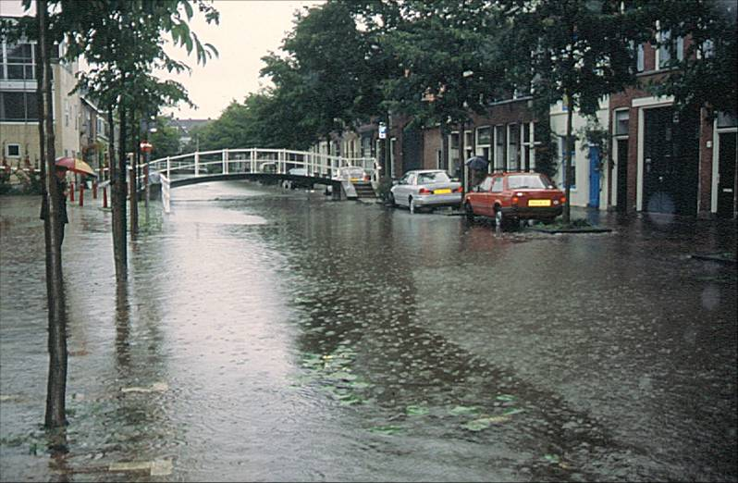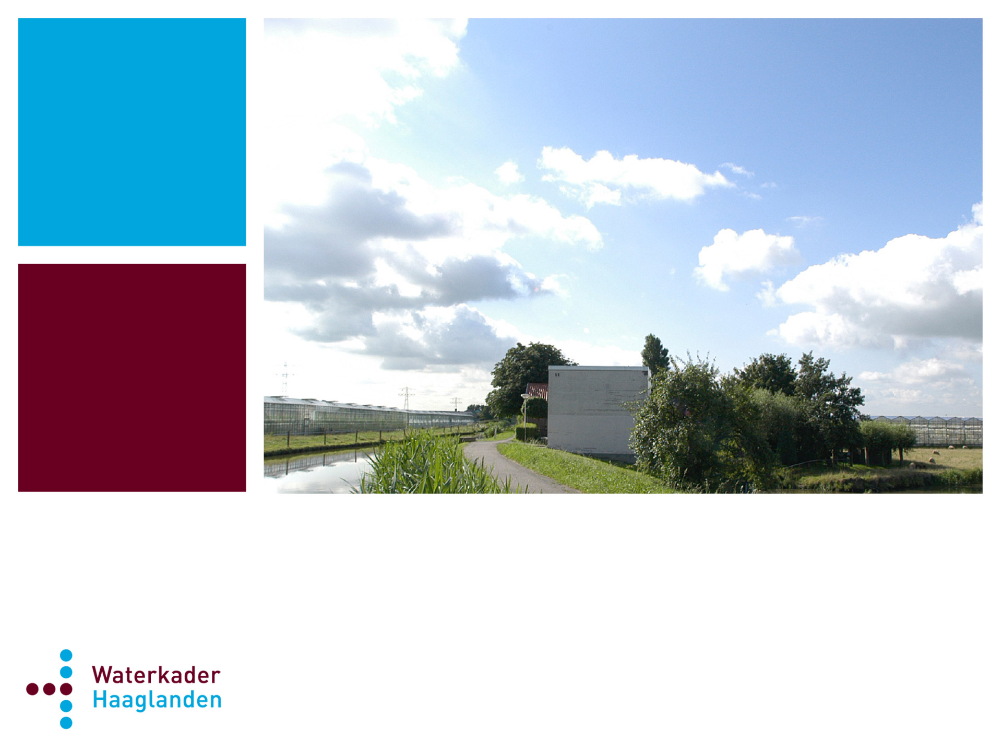This kind of climate change leads to increase of inundation and flooding of properties, an expected increase of water shortage, an expected deterioration of water quality and the Urban Heat Island (UHI-effect). For more information including a short film see: http://www.waterkaderhaaglanden.nl/?p=content&s=english
Climate change leads to:
Expected increase of inundation and flooding of properties
Expected increase of water shortage
Expected deterioration of water quality
Urban Heat Island (UHI-effect)

Contact person: Carl Paauwe: paac@haaglanden.nl

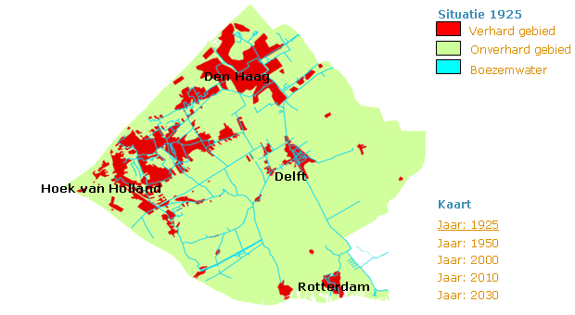
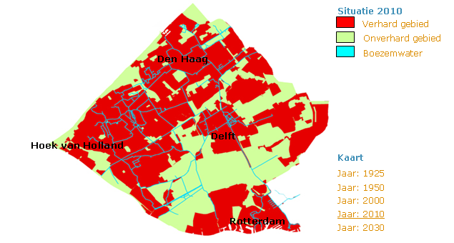
What does climate change mean for spatial planning? Where do all those changes in spatial structures lead to? What are the particular challenges for peri-urban and urban areas? To answer these questions a joint effort is required between public and private parties and knowledge institutions.
Goals:
- Develop and apply knowledge and technical processes and/ or innovative governance solutions which contribute to the water storage capacity in the region.
- Provide a contribution to development and implementation of a regional climate change adaptation strategy.
- Exchange of knowledge and experience between partners.
- Increase involvement of private parties (such as development agencies and industries)
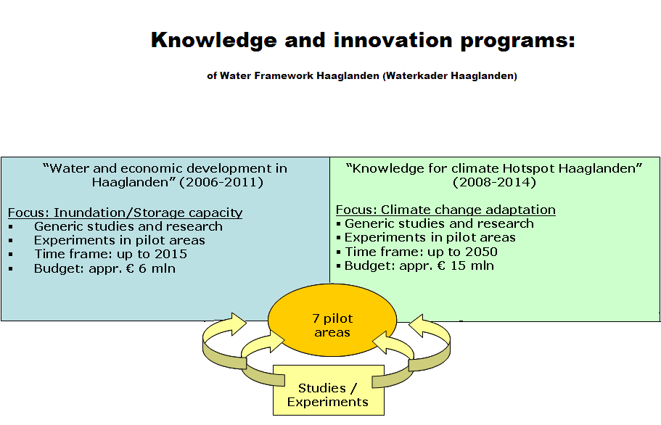
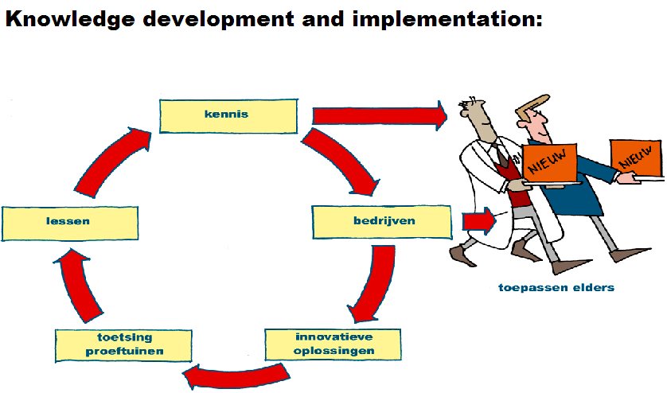

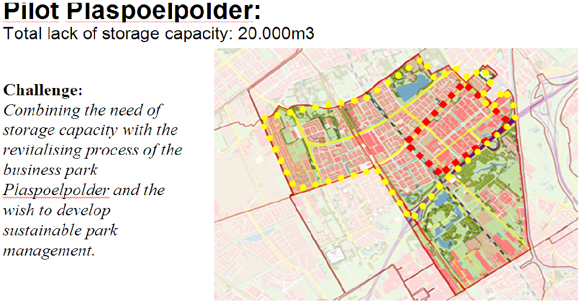
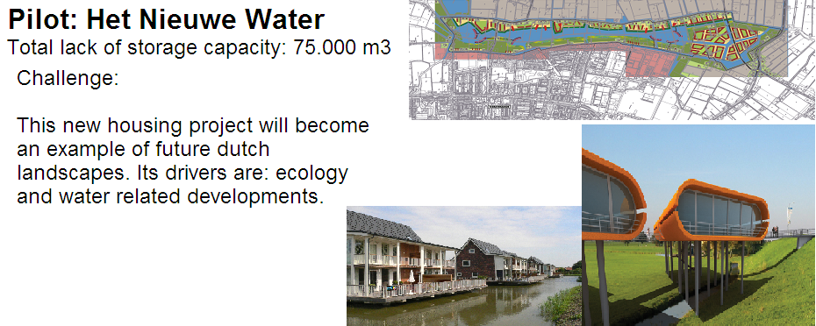
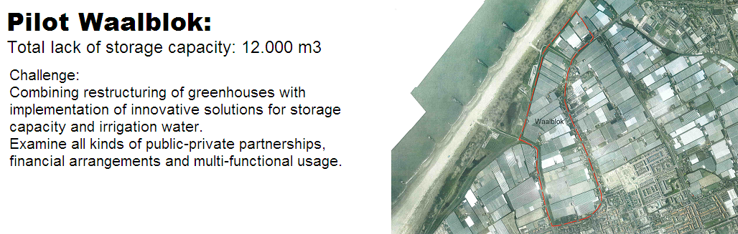
To realise the programme goals 7 pilot projects are being developed. These pilots connect science with practice. The aim is that the knowledge, once developed, will be implemented in the whole region and possibly further afield as well.

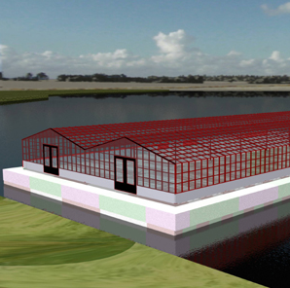
Besides these pilot areas also other projects – related to climate change and adaptation measures are currently developed:
- a study over the effects of Climate change (future scenarios and trends)
- area specific information on climate change
The Hague region as part of the Randstad aims at having a regional climate adaption strategy (including measures for implementation) by the end of 2014.
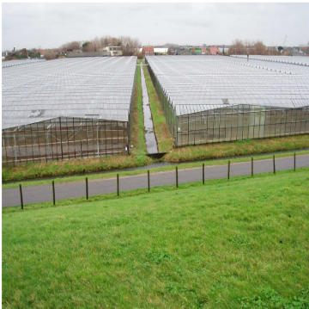
Some of the other pilots shown are exploring additional water storage capacity under open green polders, built-up neighborhoods or greenhouses. Other pilots concern innovative governance platforms for solving climate change adaptation tasks.

Mitigation

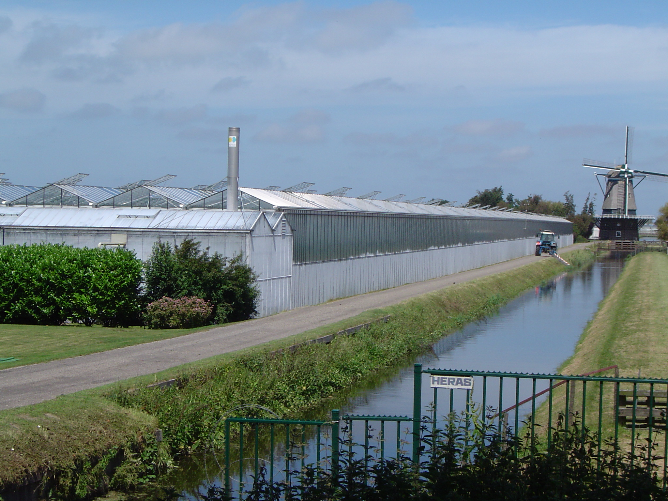
For the urban characteristics of the peri-urban regions, the Randstad invests the possibilities of as well adaptation as mitigation measures. To avoid heat stress, active cooling in buildings (for example airco’s) must therefore be prevented. The RAndstad studies therefore the stimulation of ‘passive’ buildings - buildings that use no energy for the regulation of the temperature in the summer.
When a building is cooled by a cold water well from the ground, a planning of the underground is needed so the underground can be optimal used to produce coldness. In the Randstad herefore initiative has started to create a regional vision for the underground (also for the planning of geothermal energy).
For the rural characteristics of the peri-urban region, The Water Board Delfland’s policy is to purify water sufficiently. And for this goal, more reed is planted in the region and study is started to use green biomass on a greater scale.

Mitigation measures in the Randstad

Regional Heat Network in The Hague Region (part of Randstad)
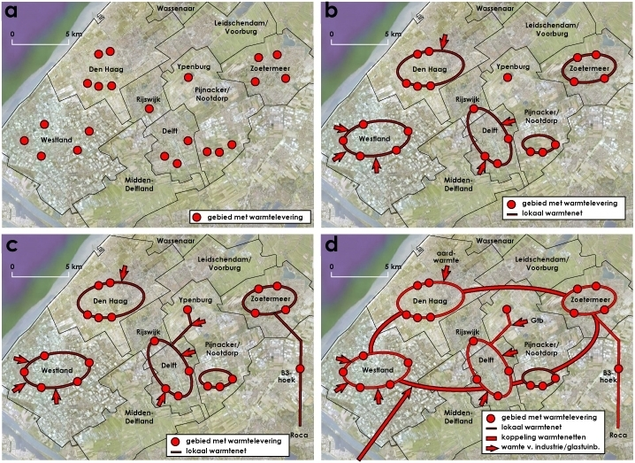
Cooperation for stimulating local heat networks which will be connected to the regional heating network.
The regional network is a collective heat network for heating homes and buildings, resulting in substantial reduction of CO2 and in clean, reliable and affordable heating for the region’s residents.
Heating from sea water (Duindorp)
Heating and cooling of 800 new dwellings with sea water, with the help of water pump systems.
New neighbourhood ‘Spoorwijk Vlamloze’
Heating and cooling of 750 new dwellings with sun collectors combines with underground ‘heating-cooling’ storage.
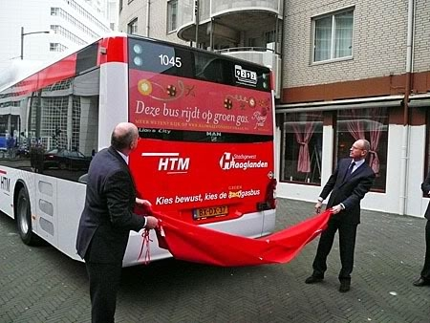
Housing ++ Energy saving for existing dwellings
Campaign where private house owners are being stimulated to take up energy saving measures. It is a ‘one stop shop’ policy.
The owners are being spared the research and the execution of the measures themselves.
Public Transport busses on green gas (HTM)
The city busses in The Hague are running climate neutral, because they run on green gas (biogas). The regional busses run on earth gas and are planning to transfer to biogas in the
future and improve the quality of the air.

